COSMIC PLAYGROUND
FAV ICON MISSING

IN MENU BAR KEEP REGISTRATION AND KEEP LOGIN AND REGISTER AS BUTTONS


IN LOGIN AND REGISTER PAGE REMOVE MENU AND FOOTER
AND KEEP LOGO
ADD FORGOT PASSWORD IN LOGIN PAGE

IN HOME PAGE ALIGNMENT ISSUE
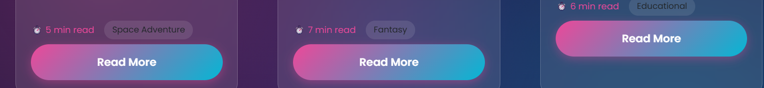

IN HOME PAGE ALIGNMENT ISSUE IN EXPLORE MORE

IN FOOTER CHANGE TO 2025


ADD WEBSITE LOGO IN FOOTER


ADD SOCIAL CONNECT IN FOOTER

IN STORIES PAGE ALIGNMENT ISSUE

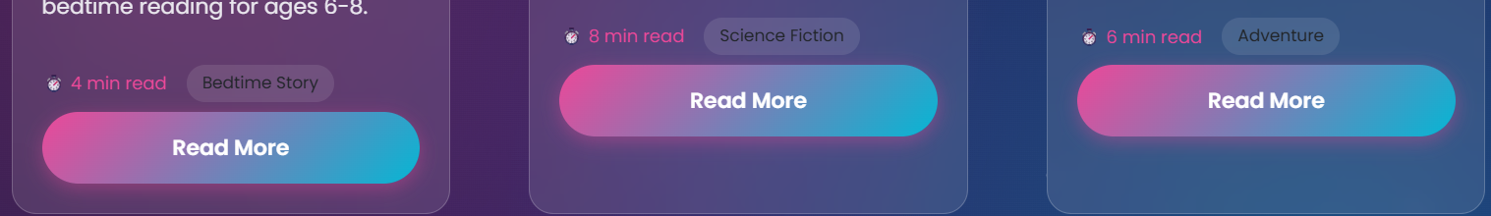
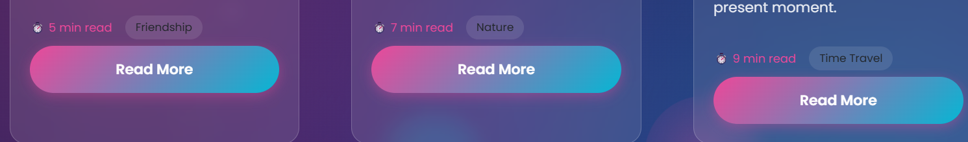
ADD IMAGES TO THIS 6 CARDS IN STORIES PAGE
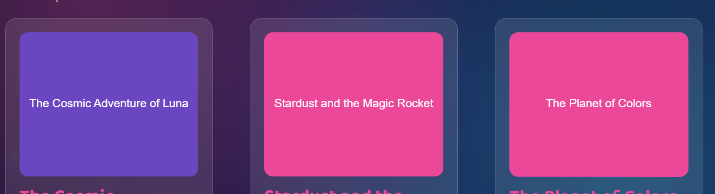
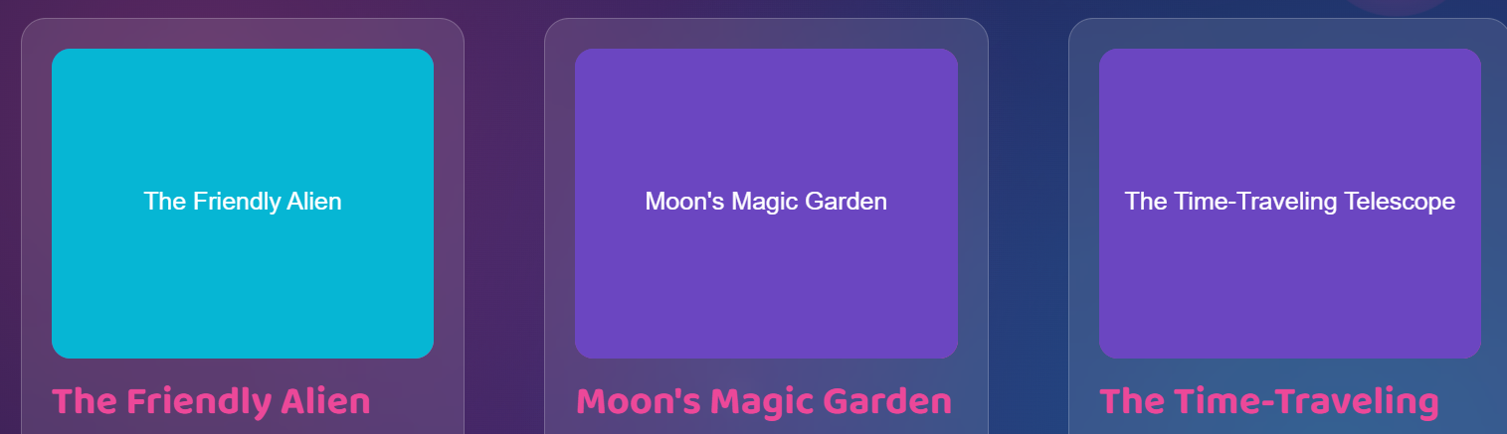
IN LEARNING PAGE ALIGNMENT ISSUE
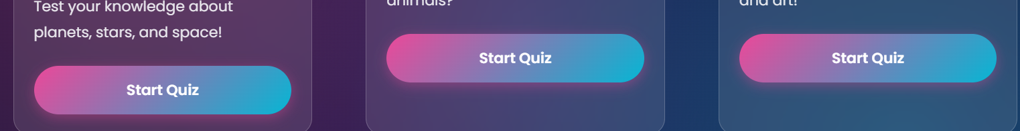

IN ARTS & CRAFTS PAGE ALIGNMENT ISSUE
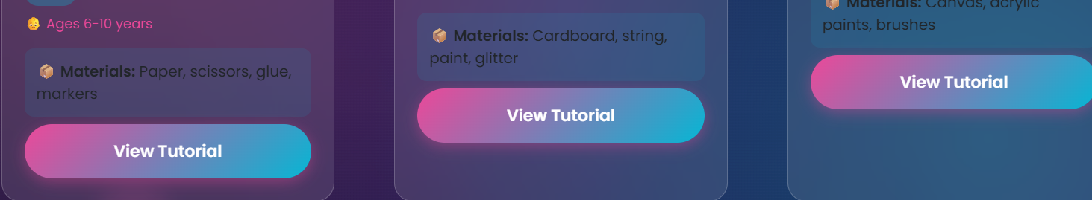
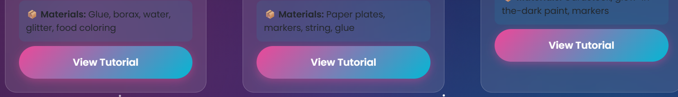
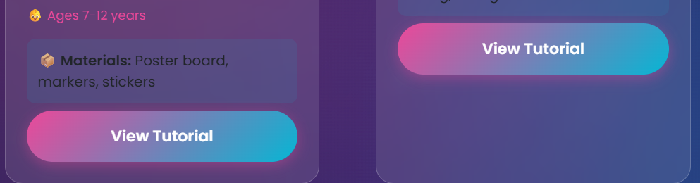

IN ARTS AND CRAFTS PAGE 6 IMAGES ARE BROKEN PLZ ADD THEM ALL
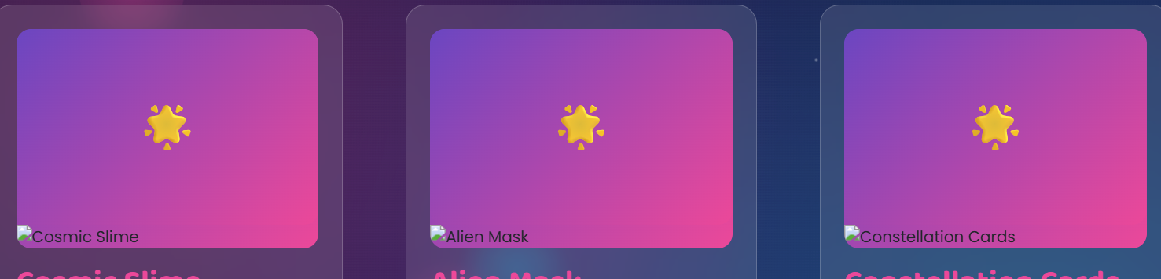

IN GAMES PAGE ALIGNMENT ISSUE
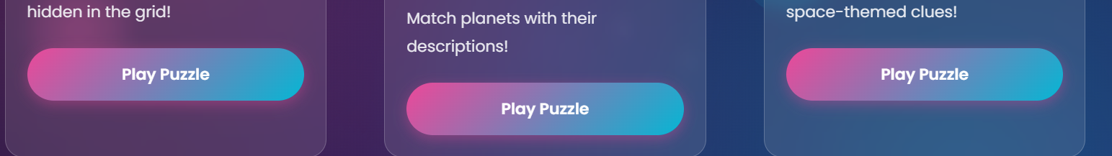
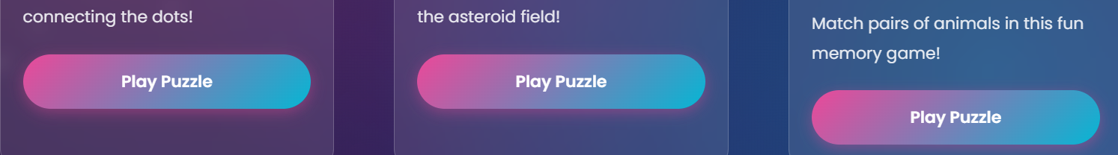
IN NATURE PAGE FUN FACT ALIGNMENT ISSUE
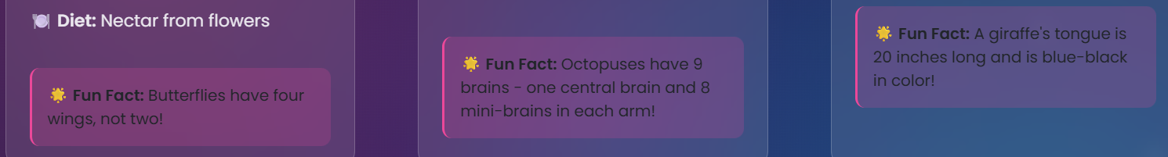
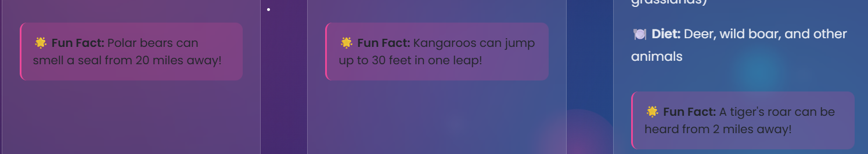
IN NATURE PAGE 6 IMAGES ARE BROKEN PLZ FIX THEM ALL
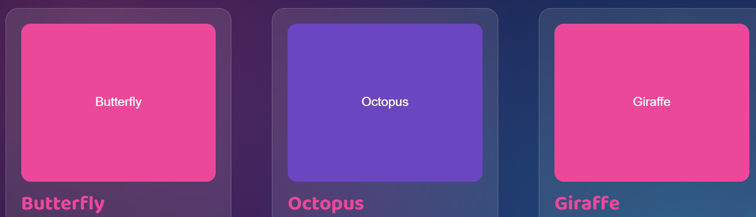

IN KIDS CORNER NEED TO DESIGN PROPERLY I DON’T UNDERSTAND
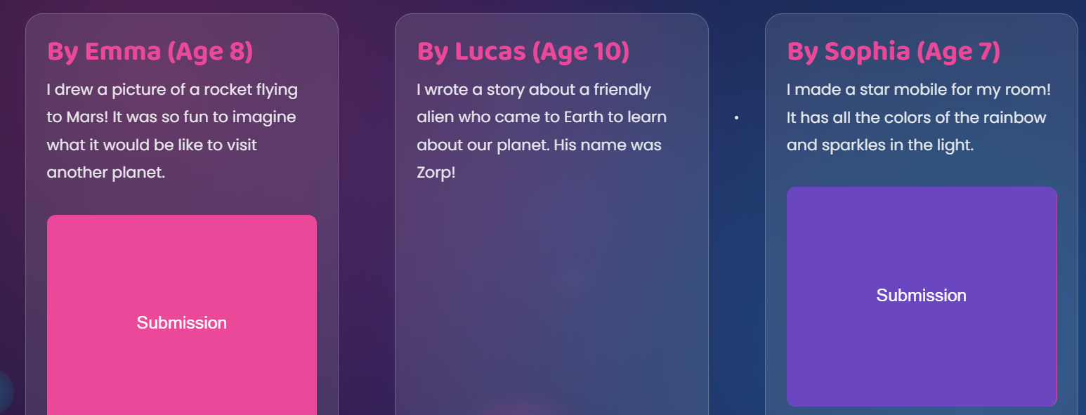
AND THIS NOT IN CTA BOX
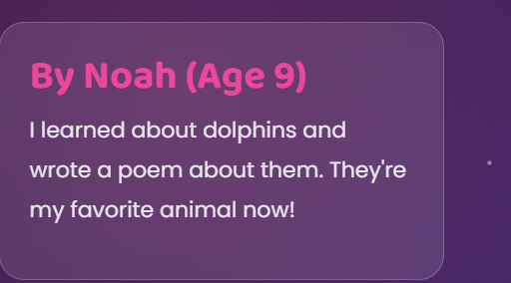
PLZ DESIGN NICELY KIDS CORNER PAGE

IN 1280*800 TAB VIEW SOME MENU NAMES COMING TWO LINES

